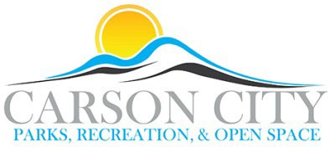

**MEMORIAL AND DONATION APPLICATION**

*(Please allow 30 calendar days for review)*

Donor Name: Click or tap here to enter text.

Donor Organization (if applicable): Click or tap here to enter text.

Address: Click or tap here to enter text.

Cell Phone: Click or tap here to enter text. Work Phone: Click or tap here to enter text.

Email address: Click or tap here to enter text.

Park, Trail, Open Space or Facility for Donation: Click or tap here to enter text.

Proposed Location within Park, Trail or Facility: Click or tap here to enter text.

Description (Tree, adoption, bench etc.): Click or tap here to enter text.

Tree Species Desired (Must meet Department specification): Click or tap here to enter text.

Other item description: Click or tap here to enter text.

Plaque*: Yes No (Plaque is only for park amenity option)

*Plaques will be provided by donor and must meet specifications before approval and installation.

Memorial gifts to Carson City are considered outright and unrestricted donations. The City does not guarantee permanency of the accepted memorial. If a memorial must be removed or relocated, Department staff will attempt to notify the donor in writing at the address shown on this form. Donations may be tax deductible (please consult a tax professional). The donor understands and agrees with the conditions set forth in the Carson City Memorial Policy and agrees to pay the City, or approved third party contractor, all necessary funds for the proposed memorial within one month of notification of approval. Third party contractors must comply with all City requirements including, but not limited to obtaining a Carson City Business License and meeting minimum City insurance requirements. Depending on the scope of work and maintenance required, a separate agreement may be required. Further consultation by a board or commission may be required due to deed restrictions, other City policies or the historical nature of the project.

**I have read and understand the Carson City Memorial Policy.**

Signature of Donor Date Click or tap to enter a date.

Mail or email completed application to:

Department Business Manager

Carson City Parks, Recreation and Open Space Department 3303 Butti Way, Bldg. 9

Carson City, NV 89701

Phone (775) 887-2262 [ccpr@carson.org](mailto:ccpr@carson.org)

**FOR OFFICE USE ONLY**

Accepted By ___________________________________________________ Date _______________ Estimated Cost $______________ Paid $___________________________ Date ________________ Exact location verified ___________________________________________ Date ________________ Inscription proof reviewed by donor _________________________________ Date _____________ Director Approved ________________________________________________ Date ________________